**Palm Sunday April 05, 2020**

**7 Lacey Court**

**Aurora, On L4G 5H2**

**905-727-3311**

**www.blessaurora.com**

**AS WE GATHER**

L: Palm Sunday begins with unbridled joy as we recall how Jesus entered Jerusalem riding on a donkey, while being acclaimed by the crowds with loud shouts of “Hosanna” and boisterous waving of palm branches. So today we begin with songs of praise and waving of palm branches as we hail Jesus as the One worthy of all glory, laud, and honor. But then the solemnness of Holy Week also begins. With a time of silence, the service shifts our focus to Jesus’ path to the cross. As foretold by prophets long ago, Jesus was stricken and afflicted, beaten and spit upon, crucified, and He died. He did this out of divine love for all of humanity, taking on Himself the sins of all people for our forgiveness. Today’s worship reflects the pattern of our lives. At times we experience unbridled joy and celebration. And then, sometimes in the next moment, we experience heartbreaking suffering. Jesus is there with us—in the joyful celebrations, in the heartbreak and suffering. He alone can transform it all into deeper love for God and neighbor. The hour of Jesus’ death on the cross is the hour of our life and salvation.

The sign of the cross **✙** may be made by all in remembrance of your Baptism.

L: In the name of the Father and of the Son and of the Holy Spirit.

**C: Amen.**

**OPENING HYMN**

LSB 442 - All Glory, Laud, and Honor

<https://www.youtube.com/watch?v=h3a8fTTrAdE>

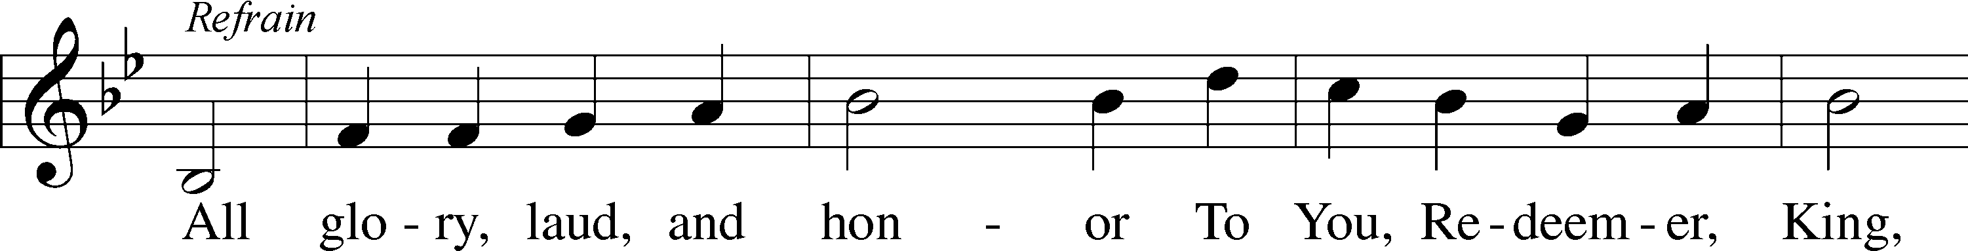

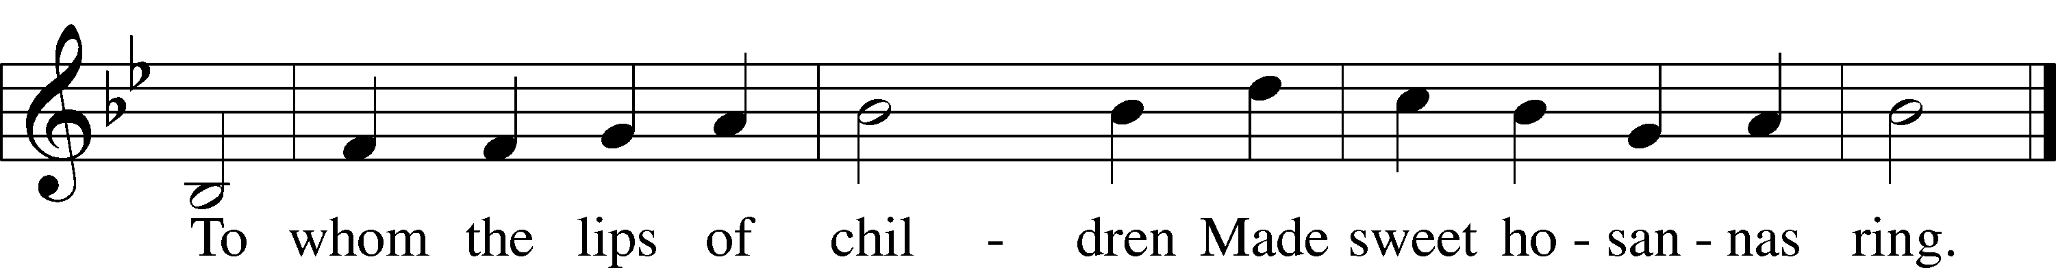

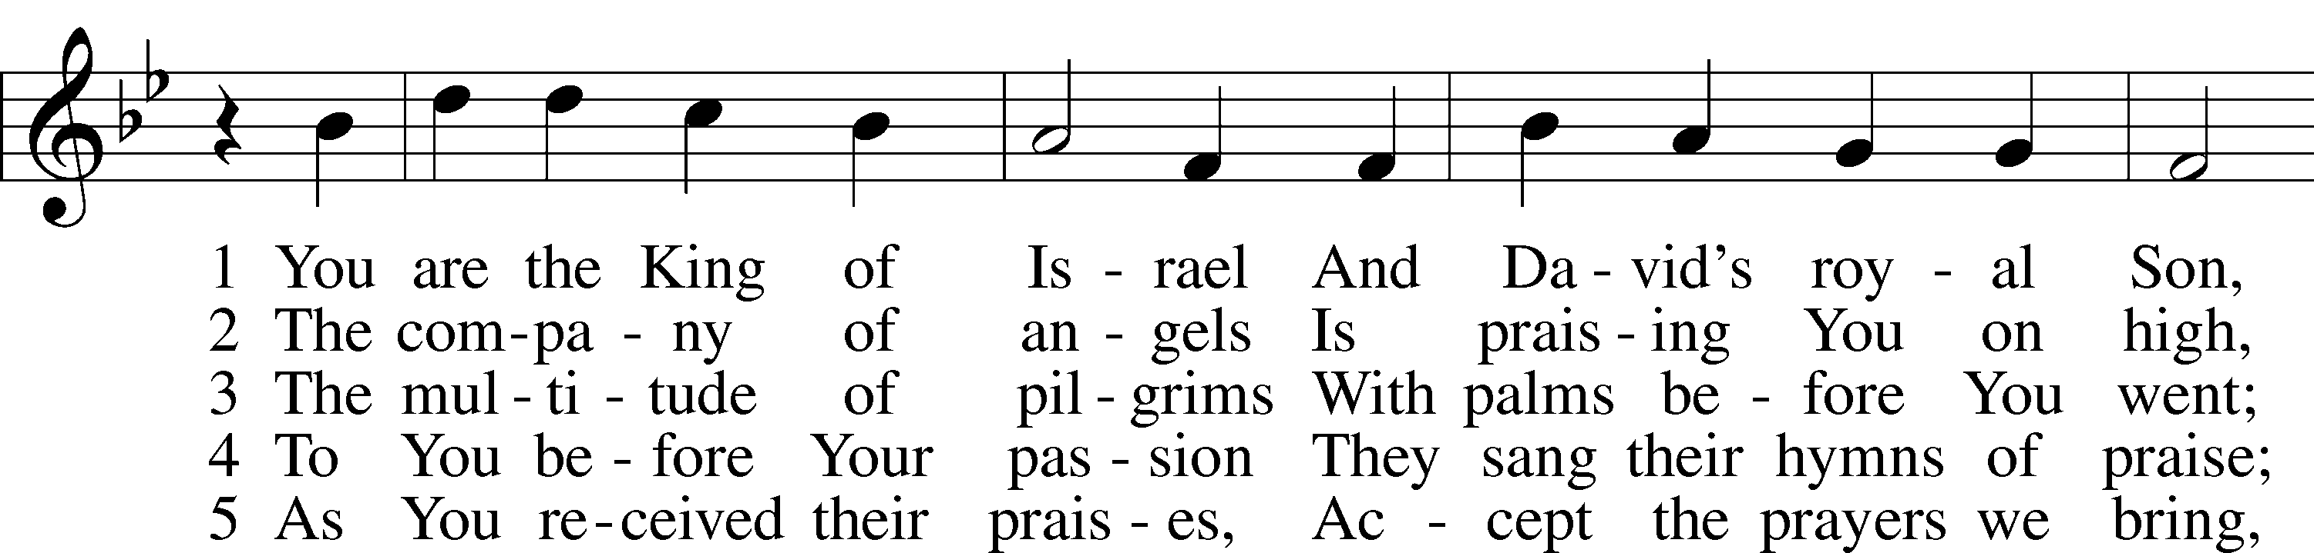

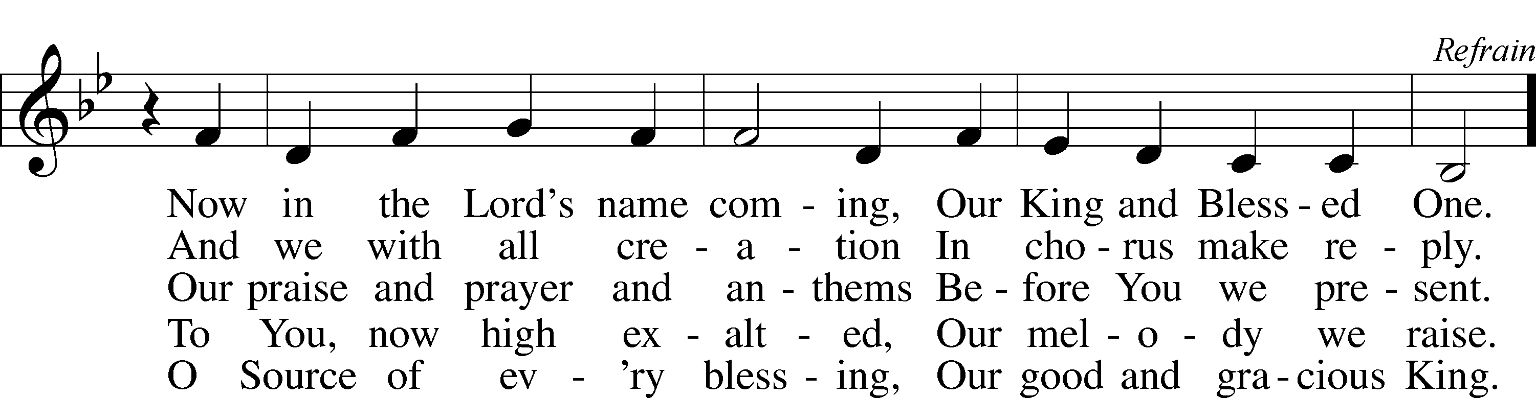

**CONFESSION AND ABSOLUTION P. 184**

L: In the name of the Father, and of the Son, and of the Holy Spirit

**C: Amen**

L: Beloved in the Lord! Let us draw near with a true heart and confess our sins unto God our Father, beseeching Him in the name of our Lord Jesus Christ to grant us forgiveness.

L: Our help is in the name of the Lord,

C: **who made heaven and earth.**

L: I said, I will confess my transgressions unto the Lord,

C: **and You forgave the iniquity of my sin.**

(Silence for personal confession)

L: Almighty God, our maker and redeemer, we poor sinners confess unto You that we are by nature sinful and unclean and that we have sinned against You by thought, word, and deed. Wherefore we flee for refuge to Your infinite mercy, seeking and imploring Your grace for the sake of our Lord Jesus Christ.

**C: O most merciful God, who has given Your only-begotten Son to die for us, have mercy upon us and for His sake grant us remission of all our sins; and by Your Holy Spirit increase in us true knowledge of You and of Your will and true obedience to Your Word, to the end that by Your grace we may come to everlasting life; through Jesus Christ, our Lord. Amen.**

L: Almighty God, our heavenly Father, has had mercy upon us and has given His only Son to die for us and for His sake forgives us all our sins. To those who believe on His name He gives power to become the children of God and has promised them His Holy Spirit. He that believes and is baptized shall be saved.

Grant this, Lord, unto us all.

**C: Amen.**

**INTROIT (Psalm): P. 186**

(Psalm 24:7-10; antiphon: Psalm 118:26)

L: Blessed is he who comes in the name of the LORD!

**C: We bless you from the house of the LORD.**

L: Lift up your heads, O gates! And be lifted up, O ancient doors,

**C: that the King of glory may come in.**

L: Who is this King of glory?

**C: The LORD, strong and mighty, the LORD, mighty in battle!**

L: Lift up your heads, O gates! And lift them up, O ancient doors,

**C: that the King of glory may come in.**

L: Who is this King of glory?

**C: The LORD of hosts, he is the King of glory!**

L: Blessed is he who comes in the name of the LORD!

**C: We bless you from the house of the LORD.**

**GLORIA PATRI………………………………………P.186**

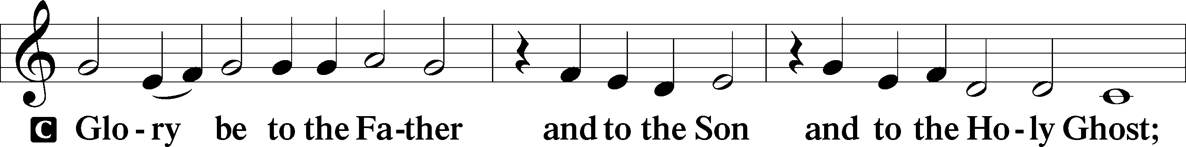

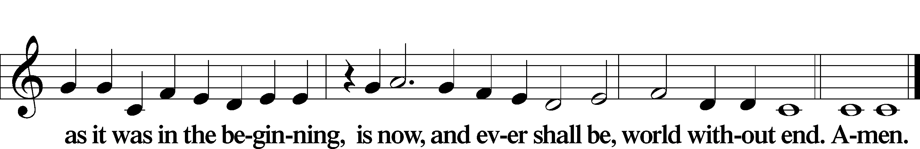

**KYRIE…………………………………………………P.186**

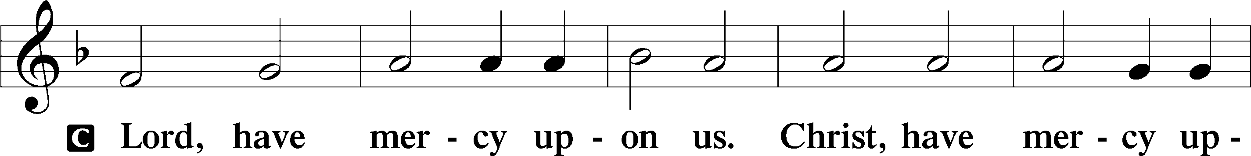

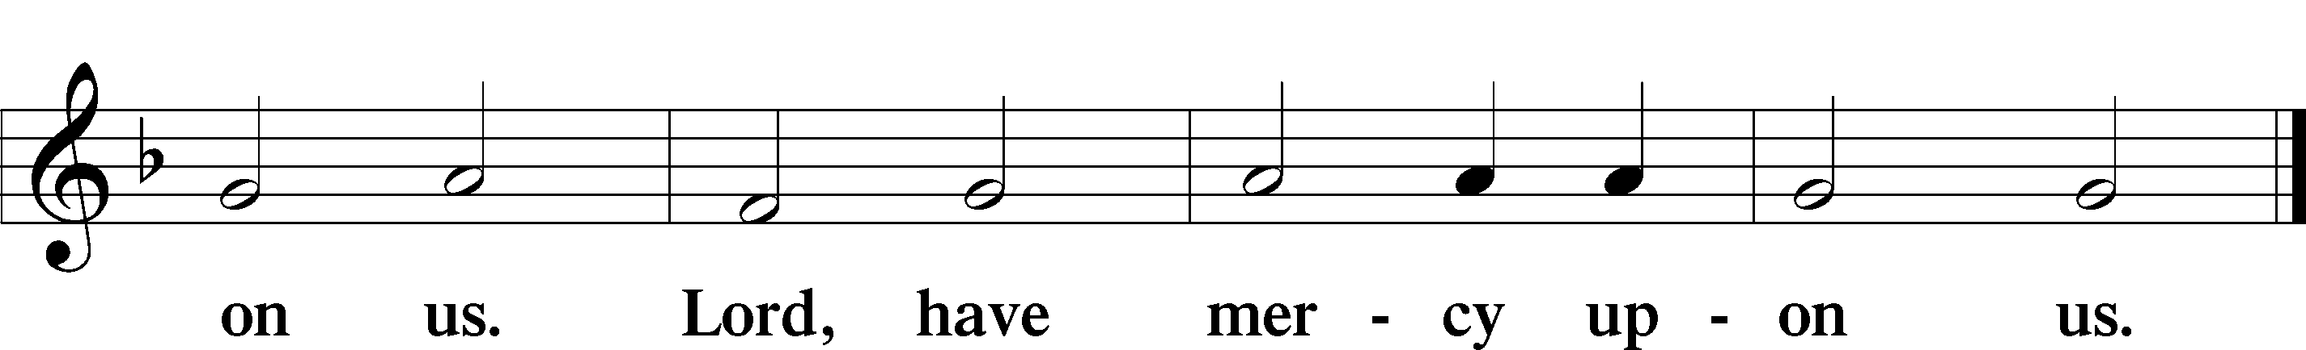

**SALUTATION AND COLLECT P. 189**

L: The Lord be with You

**C: and also with you.**

**COLLECT OF THE DAY**

L: Let us pray.

Almighty and everlasting God, You sent Your Son, our Savior Jesus Christ, to take upon Himself our flesh and to suffer death upon the cross. Mercifully grant that we may follow the example of His great humility and patience and be made partakers of His resurrection; through the same Jesus Christ, our Lord, who lives and reigns with You and the Holy Spirit, one God, now and forever.

**C: Amen.**

**FIRST READING Isaiah 50:4-9a**

R: The Sovereign Lord has given me a well-instructed tongue,

to know the word that sustains the weary.

He wakens me morning by morning,

wakens my ear to listen like one being instructed.

The Sovereign Lord has opened my ears;

I have not been rebellious,

I have not turned away.

I offered my back to those who beat me,

my cheeks to those who pulled out my beard;

I did not hide my face

from mocking and spitting.

Because the Sovereign Lord helps me,

I will not be disgraced.

Therefore have I set my face like flint,

and I know I will not be put to shame.

He who vindicates me is near.

Who then will bring charges against me?

Let us face each other!

Who is my accuser?

Let him confront me!

It is the Sovereign Lord who helps me.

Who will condemn me?

R: This is the Word of the Lord.

**C: Thanks be to God.**

**SECOND READING Philippians 2:5-11**

R: In your relationships with one another, have the same mindset as Christ Jesus:

Who, being in very nature God,

did not consider equality with God something to be used to his own advantage;

rather, he made himself nothing

by taking the very nature of a servant,

being made in human likeness.

And being found in appearance as a man,

he humbled himself

by becoming obedient to death—

even death on a cross!

Therefore God exalted him to the highest place

and gave him the name that is above every name,

that at the name of Jesus every knee should bow,

in heaven and on earth and under the earth,

and every tongue acknowledge that Jesus Christ is Lord,

to the glory of God the Father.

R: This is the Word of the Lord.

**C: Thanks be to God.**

**HOLY GOSPEL John 12:12-19**

L: The Holy Gospel according to St., the twelfth chapter.

**C: Glory to You, O Lord.**

L: The next day the great crowd that had come for the festival heard that Jesus was on his way to Jerusalem. They took palm branches and went out to meet him, shouting,

"Hosanna!"

"Blessed is he who comes in the name of the Lord!"

"Blessed is the king of Israel!"

Jesus found a young donkey and sat on it, as it is written:

"Do not be afraid, Daughter Zion;

see, your king is coming,

seated on a donkey's colt."

At first his disciples did not understand all this. Only after Jesus was glorified did they realize that these things had been written about him and that these things had been done to him.

Now the crowd that was with him when he called Lazarus from the tomb and raised him from the dead continued to spread the word. Many people, because they had heard that he had performed this sign, went out to meet him. So the Pharisees said to one another, "See, this is getting us nowhere. Look how the whole world has gone after him!"

L: This is the Gospel of the Lord.

**C: Praise to You, O Christ.**

**NICENE CREED P. 191**

**I believe in one God,**

**the Father Almighty,**

**maker of heaven and earth**

**and of all things visible and invisible.**

**And in one Lord Jesus Christ,**

**the only-begotten Son of God,**

**begotten of His Father before all worlds,**

**God of God, Light of Light,**

**very God of very God,**

**begotten, not made,**

**being of one substance with the Father,**

**by whom all things were made;**

**who for us men and for our salvation**

**came down from heaven**

**and was incarnate by the Holy Spirit**

**of the virgin Mary**

**and was made man;**

**and was crucified also for us under Pontius Pilate.**

**He suffered and was buried.**

**And the third day He rose again**

**according to the Scriptures**

**and ascended into heaven**

**and sits at the right hand of the Father.**

**And He will come again with glory**

**to judge both the living and the dead,**

**whose kingdom will have no end.**

**And I believe in the Holy Spirit,**

**the Lord and giver of life,**

**who proceeds from the Father and the Son,**

**who with the Father and the Son together**

**is worshipped and glorified,**

**who spoke by the prophets.**

**And I believe in one holy Christian**

**and apostolic Church,**

**I acknowledge one Baptism for the remission of sins,**

**and I look for the resurrection of the dead**

**and the life of the world to come. Amen.**

**HYMN OF THE DAY**

LSB 443 Hosanna, Loud Hosanna

<https://www.youtube.com/watch?v=HPSKbXxpudU>

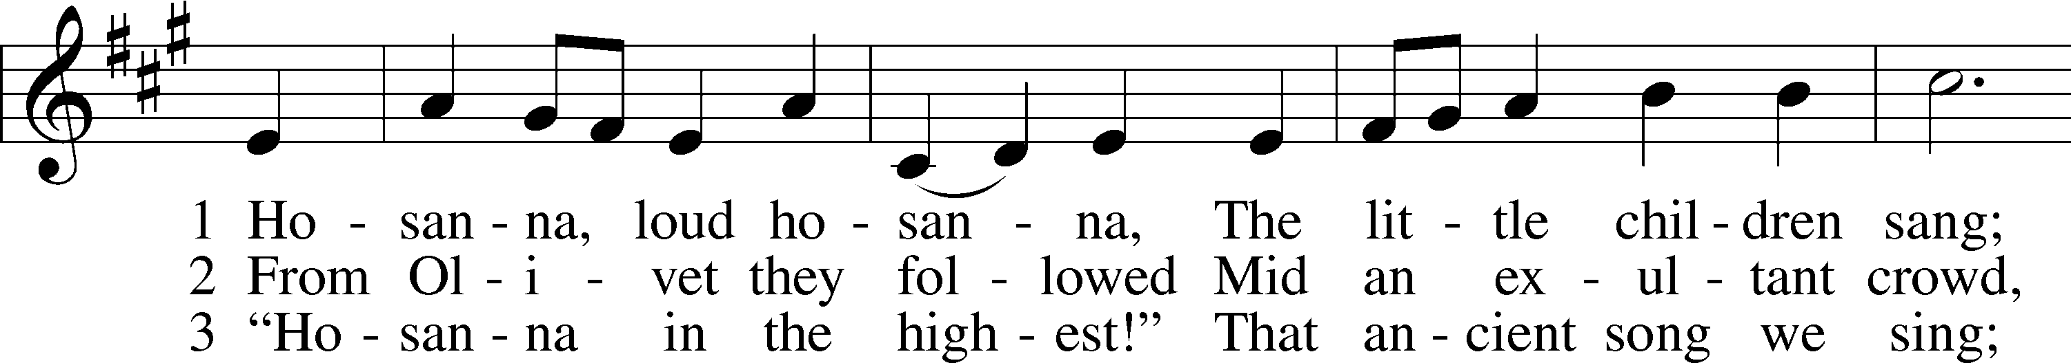

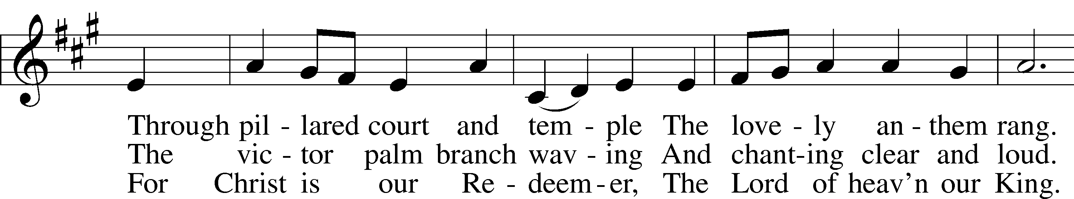

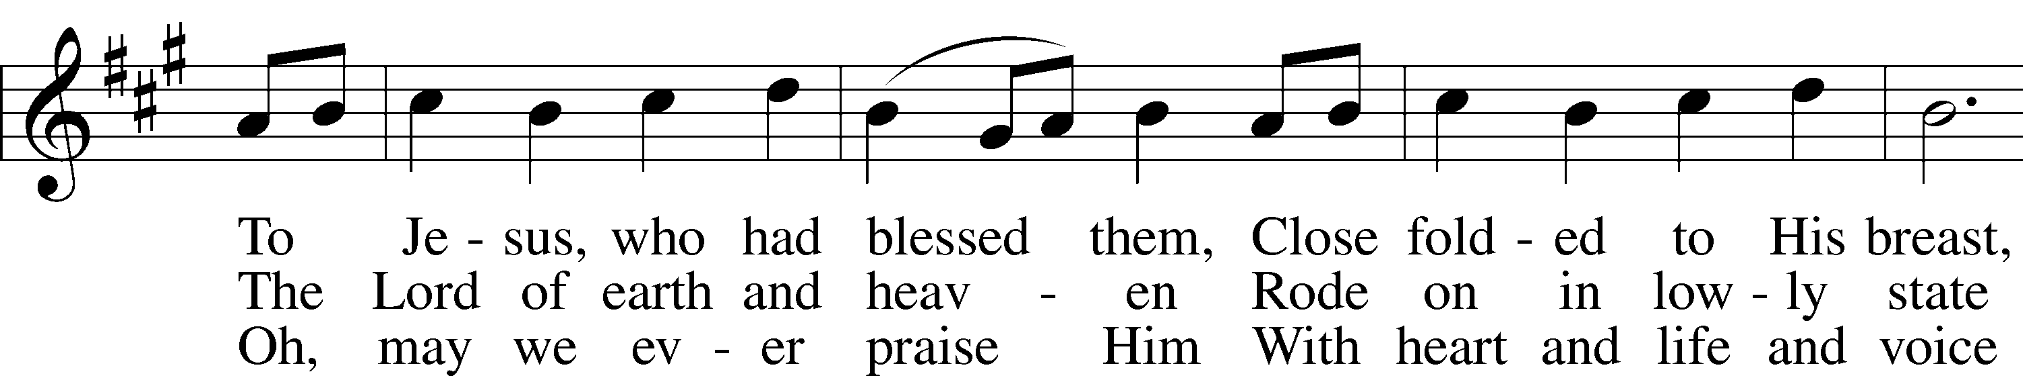

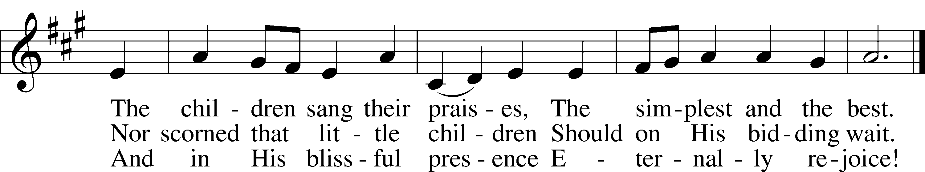

**SERMON**

**OFFERTORY………………………………………………P. 192**

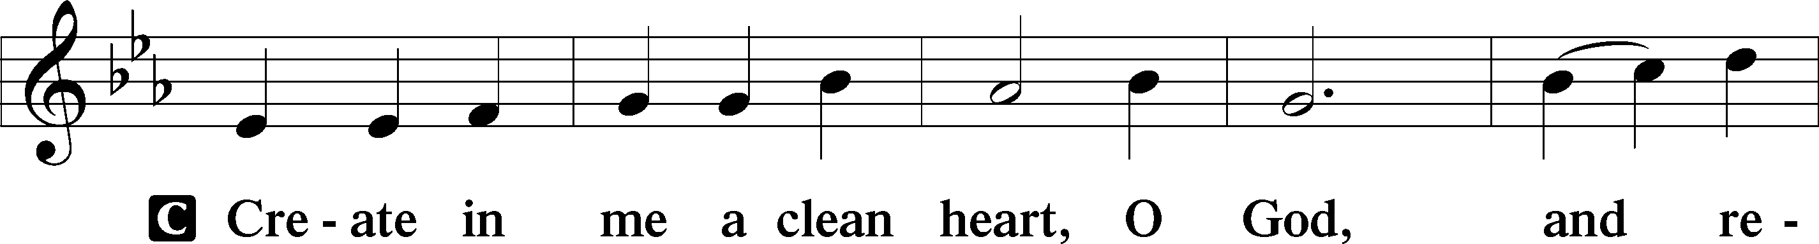

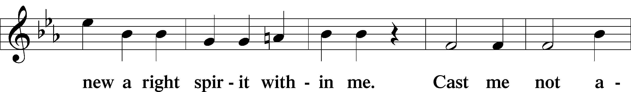

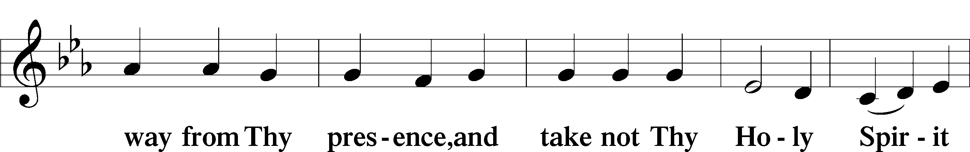

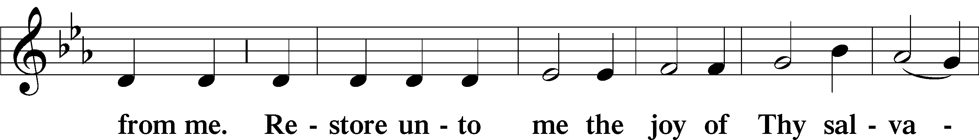

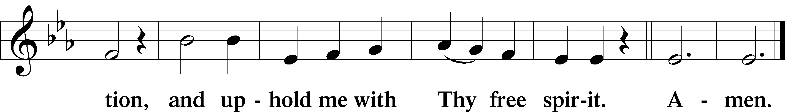

**OFFERING…………………………………………………P. 193**

**PRAYERS OF THE CHURCH................................P.193**

L: Having set out with Jesus, our Lord, on His journey to Jerusalem, let us bring our prayers to God in humility and love.

Silence for reflection

L: For the renewal of the Church in the coming holy days; for those preparing for Baptism, that they come to the waters of Baptism with joy; for all missionaries of the Church; for pastors, teachers, and all the people, let us pray to the Lord,

**C: Lord, have mercy.**

L: For leaders throughout the world, that they seek the well-being of the poor, practice good stewardship of creation, and work for peace and freedom for all; for refugees and those who provide hospitality, safety, and sustenance to victims of wars; for those who serve in harm's way, and for our enemies; let us pray to the Lord,

**C: Lord, have mercy.**

L: For the sick, the suffering, and dying, [especially . . .], that they find hope in their despair, patience in their suffering, and healing according to God's will; for those who mourn, that they find comfort in the death and resurrection of Jesus, let us pray to the Lord,

**C: Lord, have mercy.**

L: For newcomers to our congregation, that they find a warm welcome among God's people; for the families of this congregation, that we care for one another with the mind of Christ; for the safety of all who travel, let us pray to the Lord,

**C: Lord, have mercy.**

L: In times of isolation and physical distancing, when the body of Christ cannot meet in one place, we gather through the Holy Spirit in our many different places and call out to you. Heal the sick, strengthen the elderly and vulnerable, protect all from the spread of COVID-19. Support and protect all health care workers and all who serve the sick and those at high risk of infection. And trusting in your great compassion and unconditional promise always to be with us. Lord, in Your mercy,

**C: hear our prayer.**

L: We pray for the members of our church family. This week we pray for: **Megan**RaeKrim**, Erik**JohnKrim**Easten** and**Ellie**RaeKrim**, John** Kwon Wangand **Mary, Esther, Daniel** Wangand **Bonnie** and **their expecting child, Spencer** Gabin**, Ed** Fiedler**, Minkyu Jung, Mildred** Stam**, Wally** Jazenko**, Maryann** Diamsay, Lord, in Your mercy,

**C: hear our prayer.**

L: Hear our prayer, Lord God. Transform our hearts and minds during this Holy Week to be more like the heart and mind of Christ, in whose name we pray.

**C: Amen.**

**LORD'S PRAYER .P. 196**

L: Lord, remember us in Your kingdom and teach us to pray;

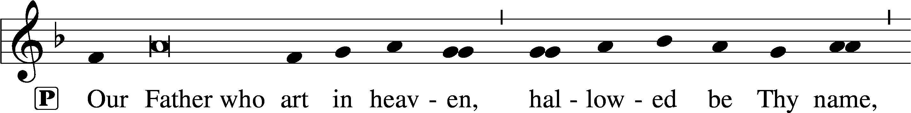

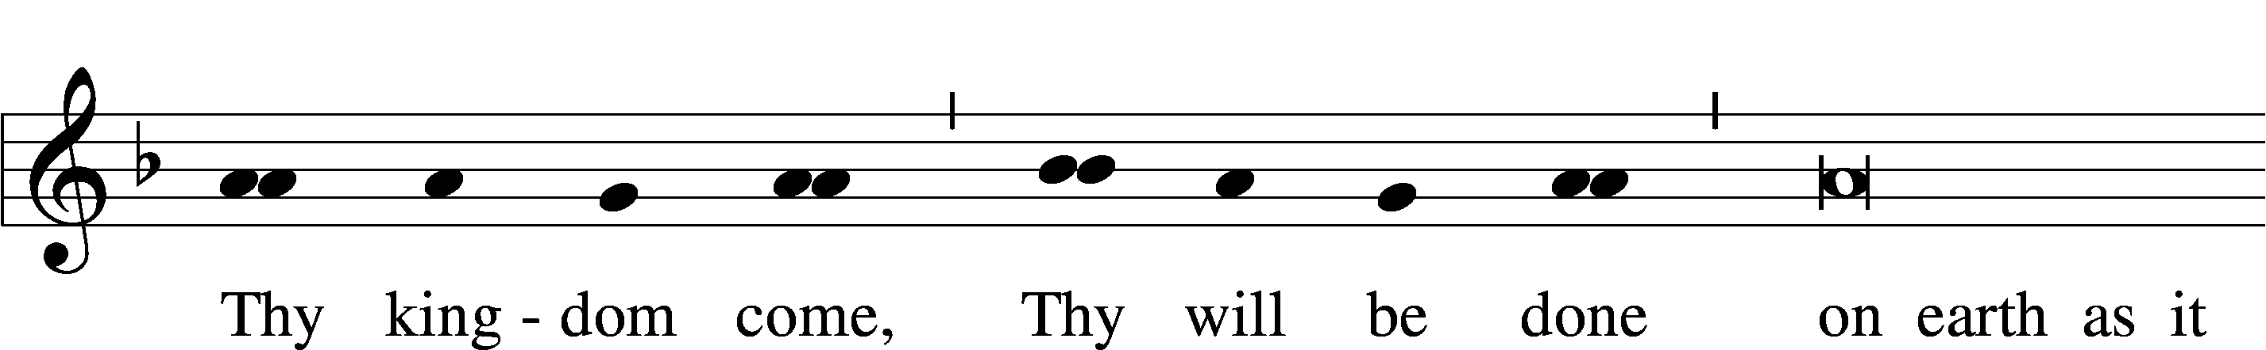

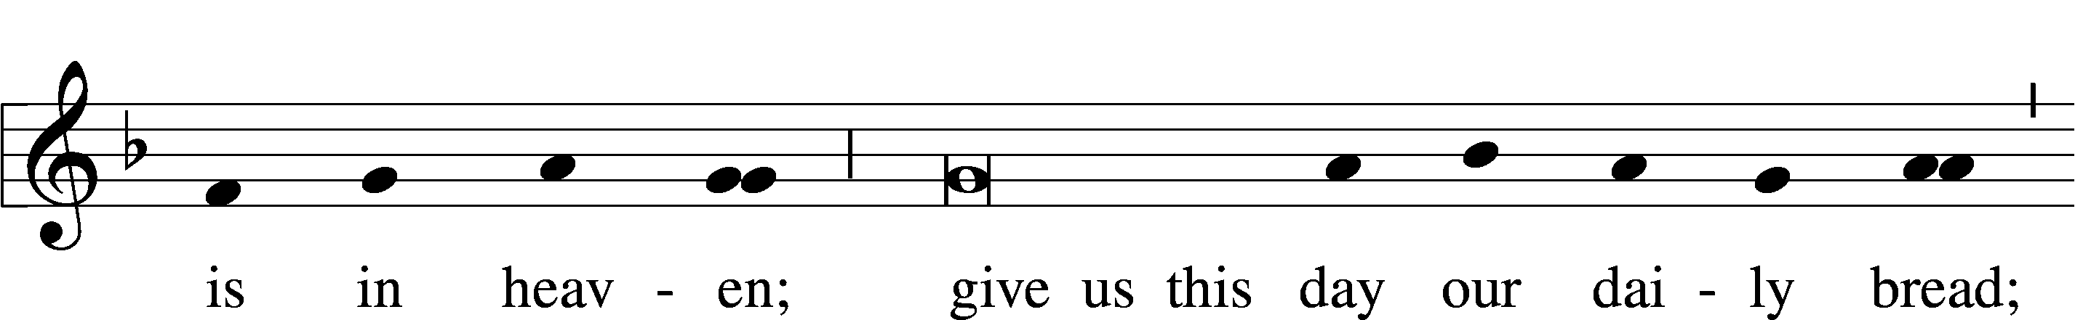

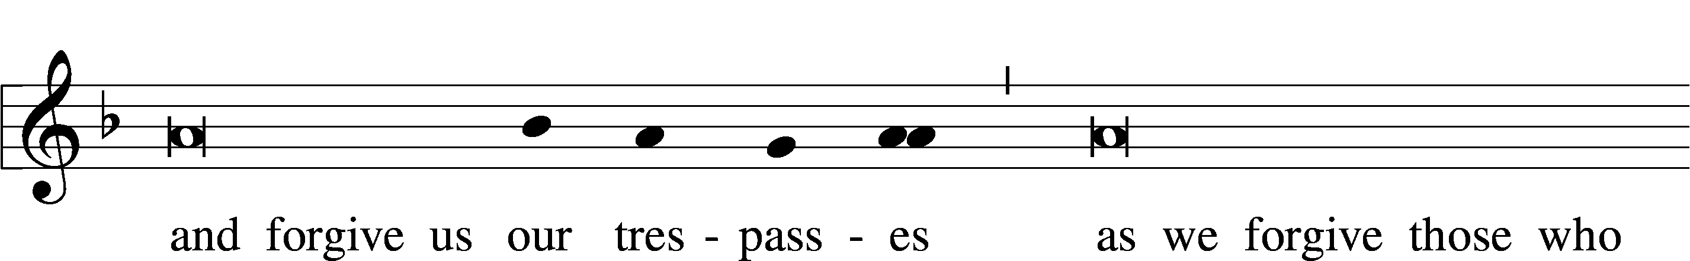

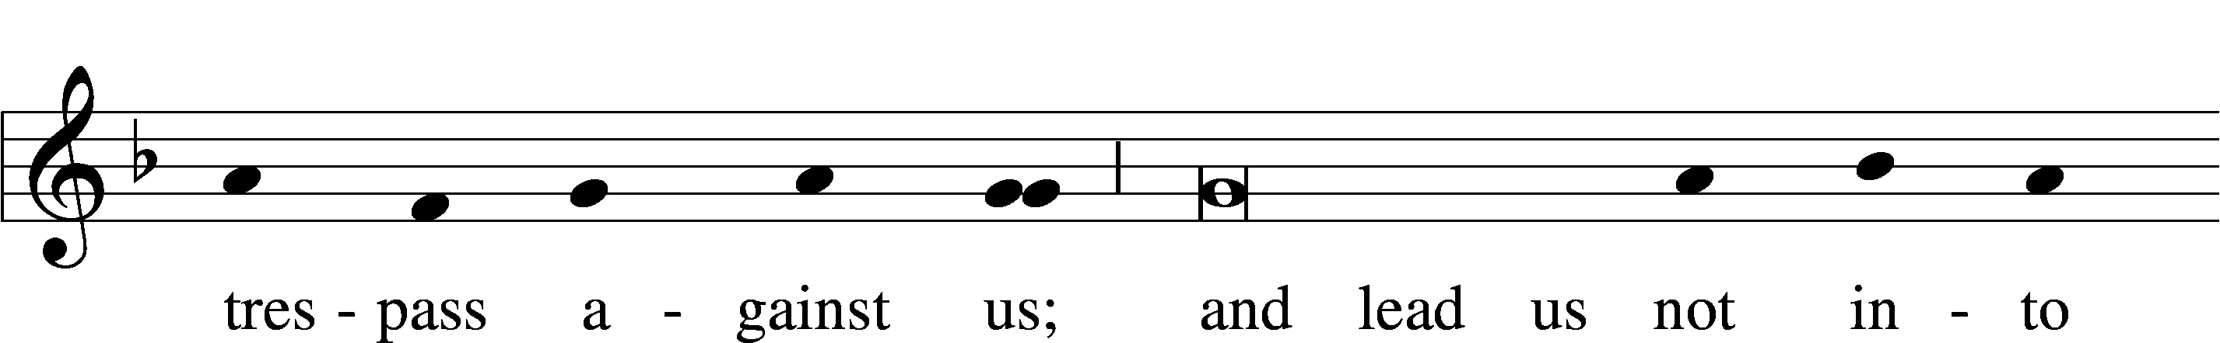

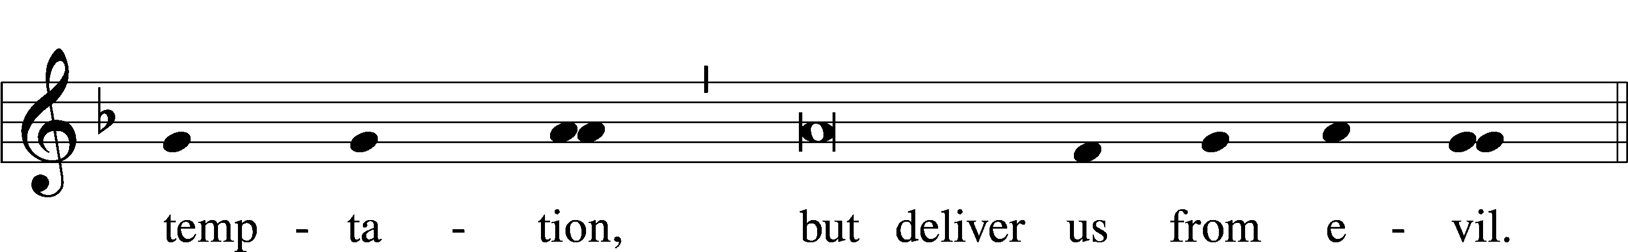

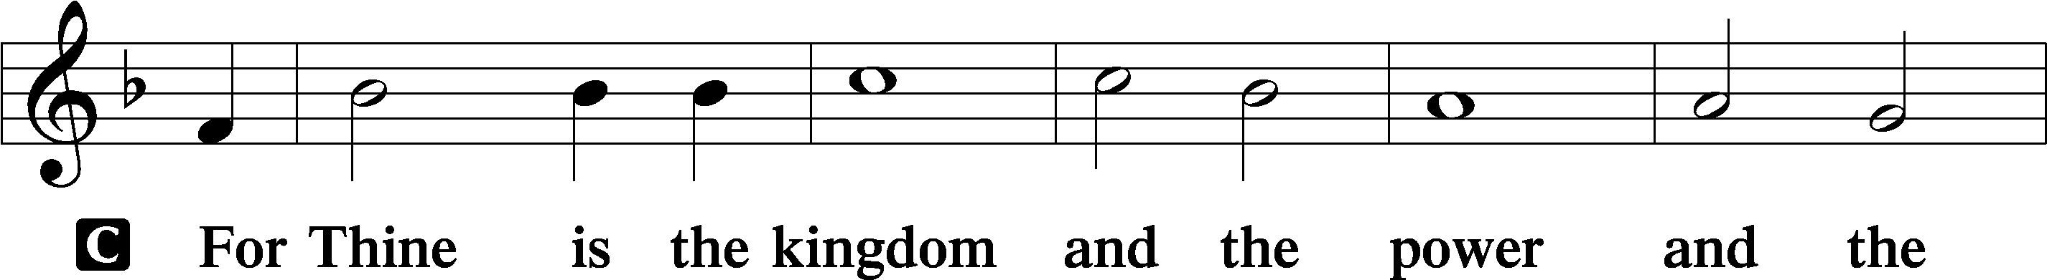

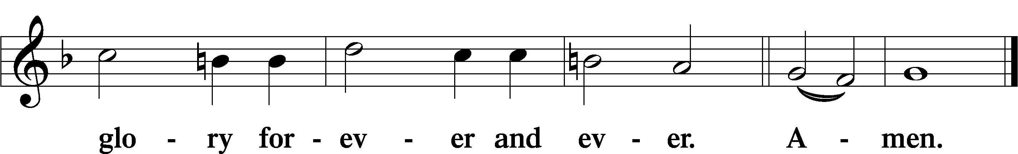

**BENEDICTION**

L: The Lord bless us and keep us.

The Lord make His face shine upon us and be gracious unto us.

The Lord lift up His countenance upon us and give us peace.

**C: Amen.**

**CLOSING HYMN**

LSB 837 Lift High the Cross

<https://www.youtube.com/watch?v=GbcBXYP4AlE>

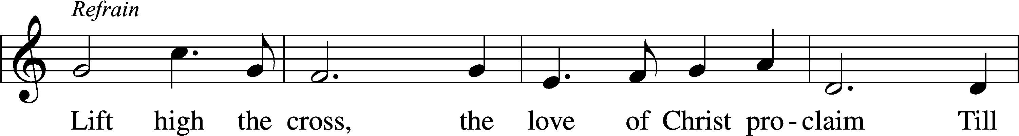

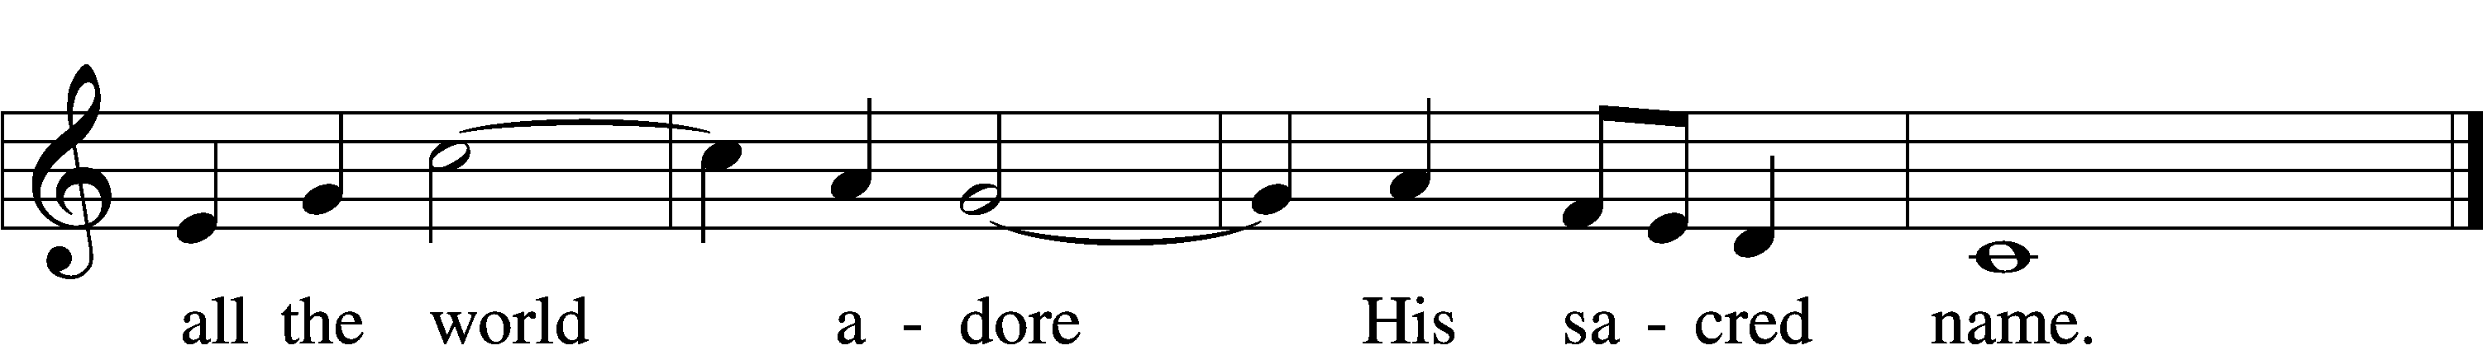

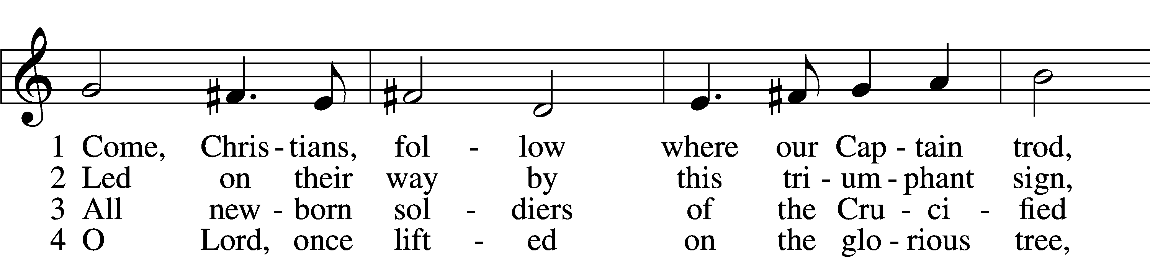

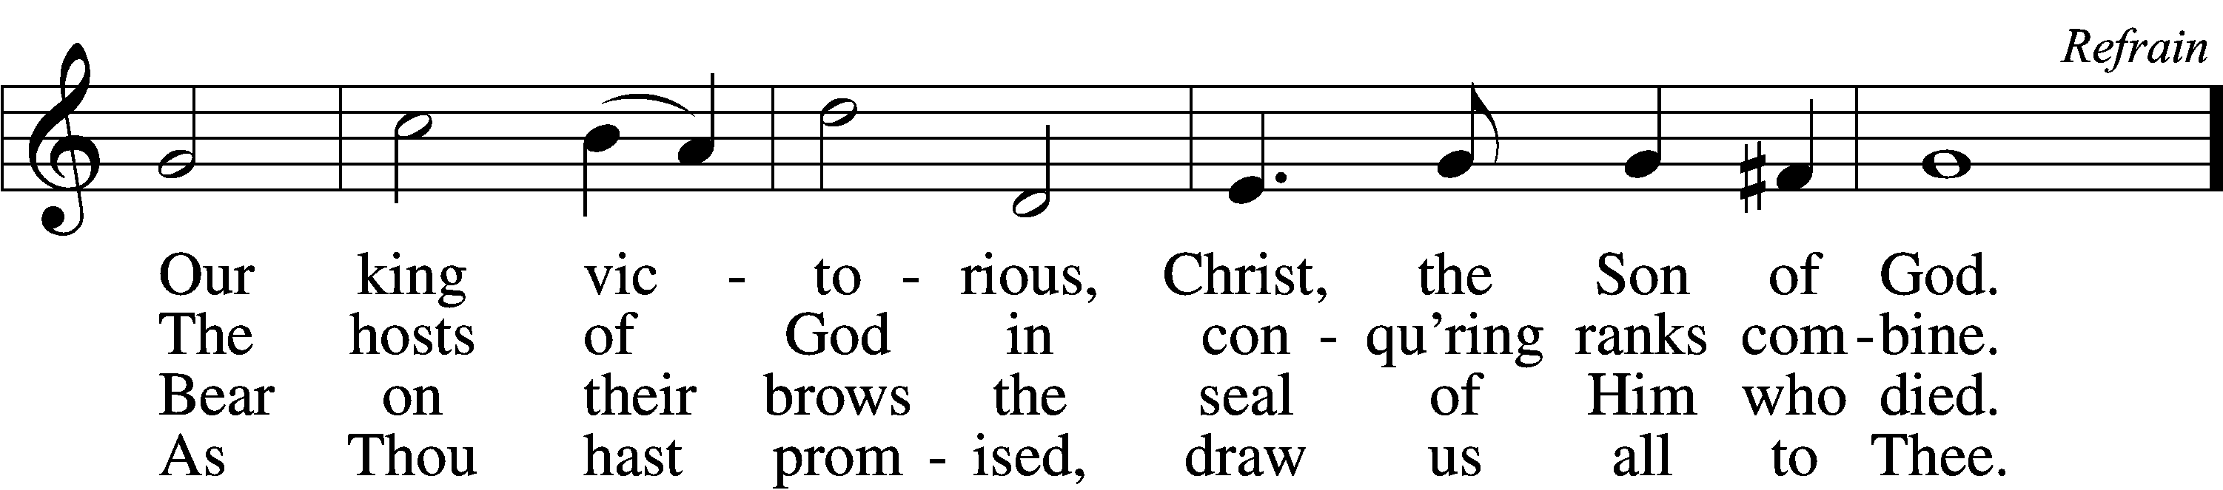

5 Let ev’ry race and ev’ry language tell  
Of Him who saves our lives from death and hell. Refrain

6 So shall our song of triumph ever be:  
Praise to the Crucified for victory! Refrain

Tune and text: © 1974 Hope Publishing Co. Used by permission: CPH Limited Promotional License no. 119000000